SUMMATIVE ASSESMENT-II

Time- 2.30 H SCIENCE-X Maximum Marks-90

01. SA.II.X.SC.Jan14. Date…………

General Instructions:

1. The question paper comprises of Two sections ,**A** and **B .**You are to attempt both the

sections.

1. All questions are compulsory.
2. All questions of Section-**A** and all questions of Section –**B** are to be attempted separately.
3. Questions numbers 1 to 3 in Sections –A are one mark questions. These are to be

answered in one word or in one sentence.

1. Question numbers 4 to 7 in Section-A are two marks questions. These are to be answered in about 30 words each.
2. Question numbers 8 to 19 Sections-A are three marks questions .These are to be answered in about 50 words each.
3. Question numbers 25 to 42 in section –B are multiple choice questions based on practical skills. Each question is one mark question .You are to select one most appropriate response out of the four provided to you.

**SECTION-A**

1. Detailed study forelimbs of mammals ,birds, reptiles and amphibians shows that the bones of

all these have same structure and points towards a common origin.

1. What conclusion can be drawn from this?

(ii) What is the term given to such forelimbs?

**2**. Draw the electron dot structure of ethyne and also draw its structural formula.

**3**. What is the information source for making proteins in the cell? State two basic events in

reproduction.

**4**. (i)Why does the sun appear reddish at sunrise?

(ii)What is Tyndall effect?

**5**. Name the element (s) of period 3 of modern periodic table which

(i) are classified as metals.

(ii) have largest atomic size.

(iii) Form(s) negative ions.

(iv) exist (s) as gases.

**6**. List any four advantages of water harvesting.

**7.** The following table shows the absolute refractive index of some material media:

|  |  |  |
| --- | --- | --- |
| S.No. | Material medium | Refractive index |
| A | Air | 1.0003 |
| B | Alcohol | 1.36 |
| C | Benzene | 1.50 |
| D | Rock salt | 1.54 |
| E | Ruby | 1.71 |

Using the above table, answer the following questions:

(i)What change takes place in the direction of a ray light when it passes from benzene to alcohol?

(ii)In which medium does the light travel the slowest?

Justify your answers in each case.

8. (i)State laws of refractions of light.

(ii)The speed of light. in a transparent medium is 0.7 times that of its speed in vacuum.

Calculate the absolute refractive index of the medium.

9.(i)Why do covalent compounds have low melting and boiling points?

(ii)Write IUPAC name of the following:

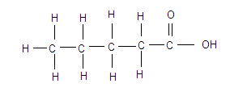

(iii)Name the gas evolved when methanol reacts with sodium metal. Write the chemical reaction.

10. How is the ozone formed in higher levels of atmosphere? Which chemical are responsible for the depletion of ozone layer?

11.(i)Define magnification produced by a lens. What does the positive sign of magnification signify?

(ii)A convex of focal length 40 cm and a concave lens of focal length 50 cm are placed in contact with each other .Calculate the (a) power. and (b) focal length of this lens combination.

12Table given below is part of periodic table:

|  |  |  |  |  |  |  |  |
| --- | --- | --- | --- | --- | --- | --- | --- |
| 1 | 2 | 13 | 14 | 15 | 16 | 17 | 18 |
| H |  |  |  |  |  |  | He |
| Li | Be | B | C | N | O | F | Ne |
| Na | Mg | L | Si | P | S | Cl | Ar |
| K | Ca | Ga | Ge | As | Se | Br | Kr |

(i) Which group elements are reactive metals and why?

(ii)Which of them has largest atomic size and why?

(iii)Which of the element is most reactive in group 17 end why?

13. What are sexually transmitted diseases? Give example of two bacterial and two viral sexually transmitted diseases.

14.Srishty ,a student of class X,met her friend who was in class IX on her way to home after school .Srishty noticed that her friend was finding it difficult to read the bus numbers and helped her to get into the bus .She enquired and found that her friend had a defect in her eyesight and had difficulty in viewing far away objects and also, she was not in a position to afford a check –up with an eye specialist .She immediately took her to a nearby ophthalmologist .The doctor advised her friend to wear spectacles and gave her to a nearby opththlmologist.The doctor advised her friend to wear spectacles and gave her the power of spectacles to be worm .She paid the doctor’s fee from the pocket money/saving and also purchased medicines prescribed by the doctor for her friend.

(i)What values do you see in Sristhy?

(ii)Explain the eye defect by which Sristhy’s friend was suffered and also, give the recitation to be adopted by ophthalmologist with a ray diagram.

15The atomic number of element is 15.

(i)Identify te element (ii) Write its electronic configuration.

(iii)Write its valence electrons and valency.

(iv)Identify the nature of oxide formed by it.

(v)Give the formula of its chloride.

(vi)Identify the group and period to which it belongs.

16. Giving an example, differentiate between acquired and inherited traits.

17. State and describe in brief any three main factors responsible for the rise of a new species.

18.(i)What are the consequences of depletion of forests?

(ii)What is the advantage of a disposable paper cup over a plastic cup?

(iii)Why is reuse better than recycling in conserving our environment?

19.Why is vegetative propagation practiced for raising some types of plants ?List any two advantages and disadvantages of vegetative propogation.

20.(i)Complete the following ray diagram .Also mark the angle of incidence end angle of reflection in each case.

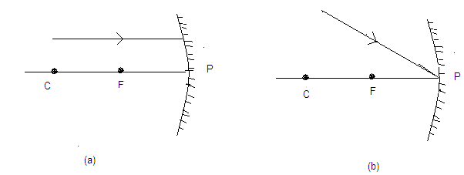

(ii)A concave mirror forms an inverted image of size double than that of object .The focal length of the mirror is 15 cm.Find the position of the image and object.

21.A compound ‘A’(molecular formulaC3H6O2)reacts with NaHCO3 to form a compound ‘B’ and evolves a gas which extinguishes fire.Compound ‘A’ on treatment with ‘C’ in presence of conc. H2SO4 forms a compound ‘D’(molecular formula C5H10O2).On addition of NaOH to ‘A’ ,it also gives ‘E’ and water ,’D’ on treatment with dilute NaOH solution gives back ‘A’ and ‘C’ .Identify A,B,C,D and E write down the reactions involved.

22. Draw a neat diagram of human female reproductive system and label the following:

(i)Part which produces female germ cell.

(ii)Part where fertilization takes place.

(iii)Part where zygote is implanted.

What changes take place in the lining of uterus

(i) before implantation,

(ii)if no fertilization occurs?

23.(i)What is meant by least distance of distinct vision ?Mention its value.

(ii)In which of the following two cases, the focal length of the eye lens will be more-

(a)When culinary muscles of a normal eye is in most relaxed state. or

(b)When ciliary muscles of a normal eye is in most contracted state.

Explain with reason.

(iii)Newton placed two triangular prisms in inverted position with respect to each. He then let white light pass through them. What was his observation on screen? State reason for such observation and draw a diagram of this experiment.

24. Draw a diagram of a pistil showing germination of pollen and label the following parts:

(i)Part that transfers male gamete to ovule.

(ii)Part which fuses with female gamete.

(iii)Part which develops into a fruit.

List the various changes that take place in flower after fertilization.

**SECTION-B**

25. Ethanoic acid is added to sodium bicarbonate solution and the gas evolved is tested with a burning splinter .The following four observations are reported:

I.The gas burns with a pop sound and the flame gets extinguished.

II.The gas does not burn but the splinter burns with a pop sound.

III.The flame extinguishes and the gas does not born,

IV.The gas burns with a blue flame and the splinter burns brightly.

The correct observation is reported in

(a)I (b)II (c) III (d)IV

26.On adding acetic acid to sodium metal,

(a) greenish yellow gas with pungent smell evolves.

(b)colourless and odourless gas evolves which bourns with ‘pop’ sound.

(c) yellow coloured odourless gas evolves.

(d)colourless gas with pungent smell evolves.

27. Soap works well in

(a)hard water (b)soft water (c)acidified water (d)very cold water.

28. Common salt is added in preparation of soap so as to

(a) favour precipitation of soap (b)act as filler

(c)prevent precipitation of soap (d)make it salty and increase its solubility.

29.Soape are cleansing agents and are

(A) sodium salts of fatty acids (b)calcium salts of fatty acids

(c) potassium salts of mineral acids (d)magnesium salts of fatty acids

30.The reaction involved in preparation of soap is called

(a)etherification (b)saponification (c) hydrogenation (d)hydration

31. Four students traced the path of a ray of light from glass to air as given below.

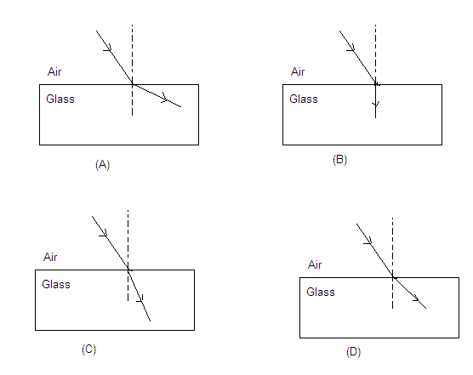

The correct path of refracted ray is shown in

1. (A) (b) (B) (c) (C) (d) (d)

32While performing an experiment to trace the path of a ray of light passing through a rectangular glass ,a ray PQ is made to incident at an angle of 400 by a student on the side AB of glass slab as shown below.

The angle of refraction observed by him would be

(a)more than 400  (b)less than 400 (c)equal to 400  (d) equal to 00

33.Which of the following .figures has been labeled correctly in an experiment to trace the path of ray light through a glass prism?

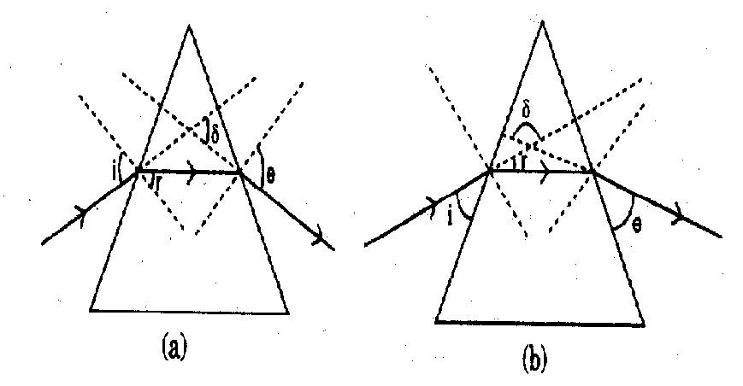

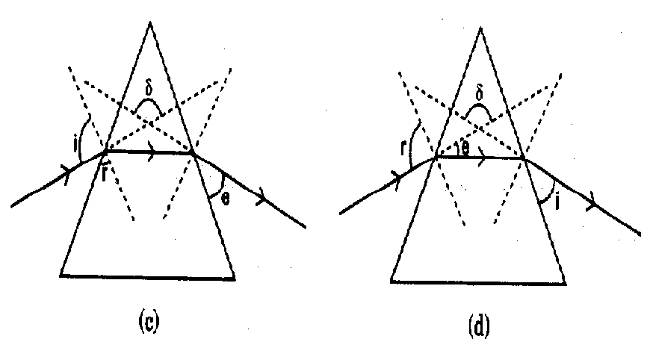

34.Th determine the focal length of a concave ,our students P,Q,R and S obtained the image of an electric pole on a well .They measured the distance as given below between:

P-electric pole the wall only

Q-electric pole and the mirror only

R-mirror and the wall only

S-electric pole and the wall and also between the electric pole and the mirror.

The correct focal length will be directly obtained by

(a)P (b)Q (C)R (d)S

35. In the laboratory, a student was provided with a convex lens whose focal length was somewhere between 15 cm to 20cm.While focusing a distant object to find out its focal length ,he should adjust the position of screen between

(a)15 cm and 20 cm marks on scale from lens

(b)20 cm and 30 cm marks on scale from lens

(c)25 cm and 30 cm marks on scale from lens.

(d)30 cm and 40 cm marks on scale from lens.

36.A virtual erect and magnified image of an object is formed by a convex lens.The position of the object is

(a) between F and 2F (b)between 2F and infinity

©at the focus (d) between F and optical centre.

37.The given slides A and B were identify by four students I,II,III and IV as stated below.

|  |  |  |
| --- | --- | --- |
|  | Slide A | Slide B |
| I | Binary fission in Amoeba | Daughter cell of Amoeba |
| II | Budding in yeast | Buds of yeast |
| III | Binary fission in Amoeba | Buds of yeasty |
| IV | Budding in yeast | Daughter of cell of Amoeba |

Of the above mentioned identification of slides A and B which one is correct?

(a)I (b)II (c)III (iv)IV

38. The mode of asexual reproduction in which parental identity is maintained is known as

(a)binary fission (b)multiple fission (c)budding (d) all of these

39. Which of the following organs is analogous to the wing of parrot?

(a)Flipper of whale (b) Foreleg of horse

(c)Wings of housefly (d) Front leg of frog.

40. Which of the following are the examples of homologous organs?

(a)Venus flytrap and spines of cactus

(b)Tendrils of cucurbits and venus flytrap

(c)Spines of barberry and fruit of lemon

(d)Venus flytrap and pitcher plant

41.The part of embryonal axis between plumule and point of attachment of cotyledons is called

(a)epicotyl (b)hypocotyls (C)radical (d)hilum

42.In which of the following options ,the part of the seed is incorrectly matched with its characteristics?

(a) Hilum - point of attachment of seed stalk

(b) Radicle - develops into future root

(c) Micropyle - absorbs water during germination

(d)Seed coat – stores food for developing embryo